Lab D - Malware Analysis

Timothy Victori

Arizona State University

IFT 202

Gary Grindle

9/7/2024

Part 1
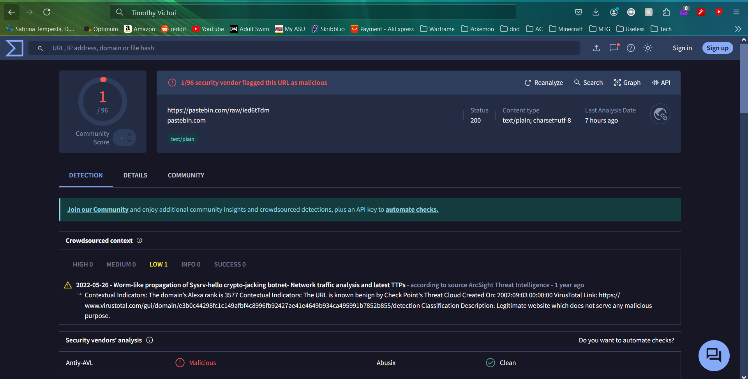
Part 2
